**Transport Section:**

Eska search bar homepage wala ki tarha bna do

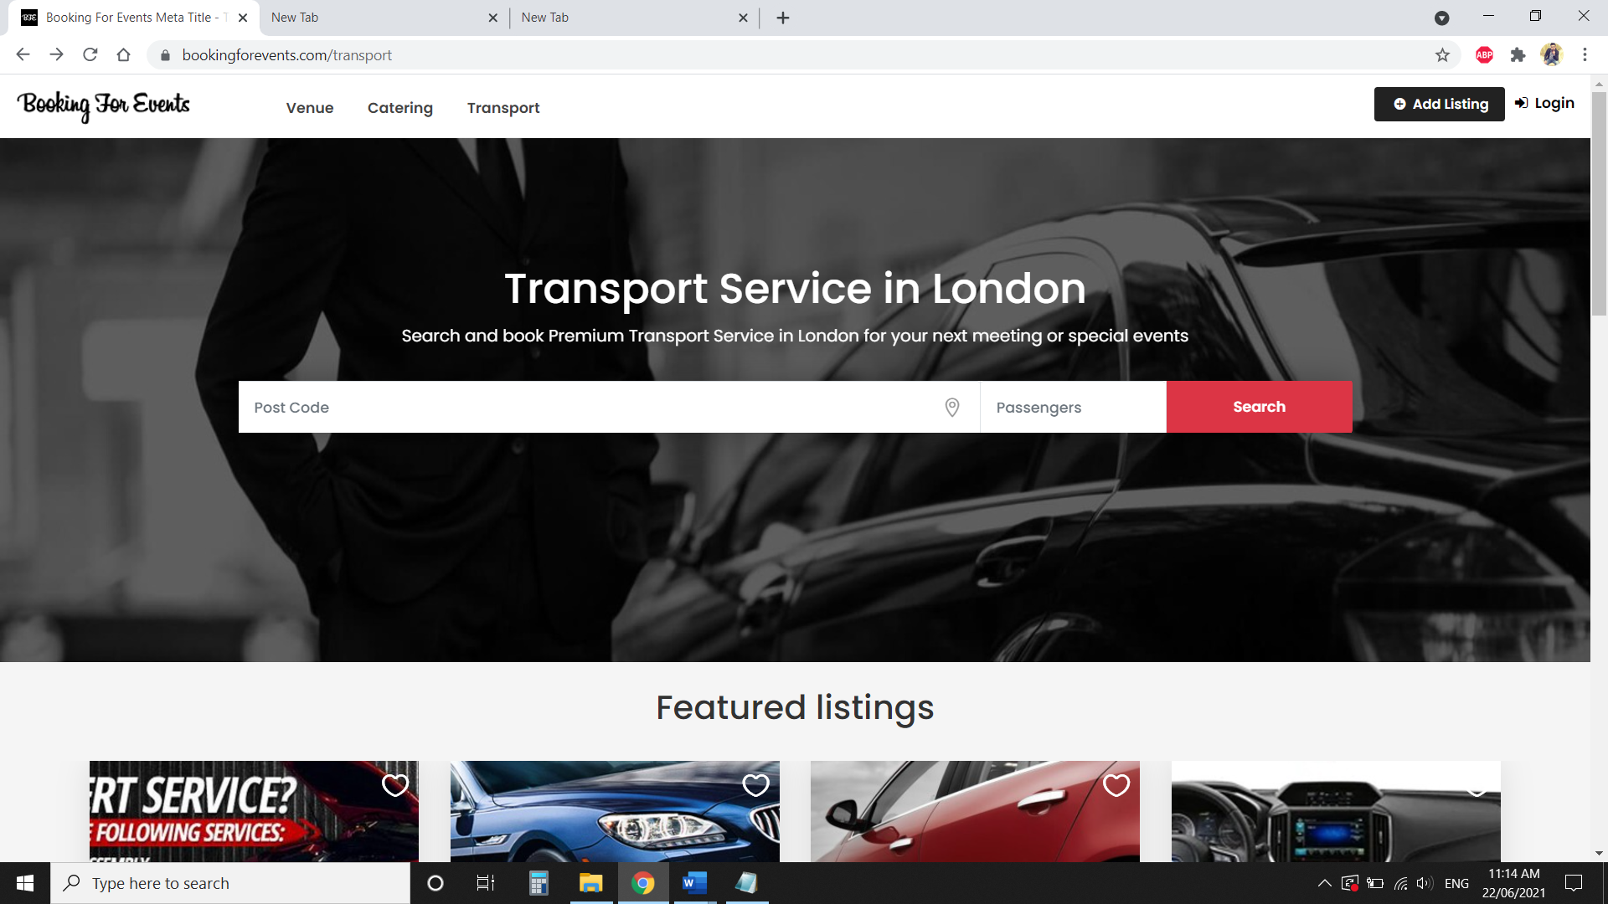

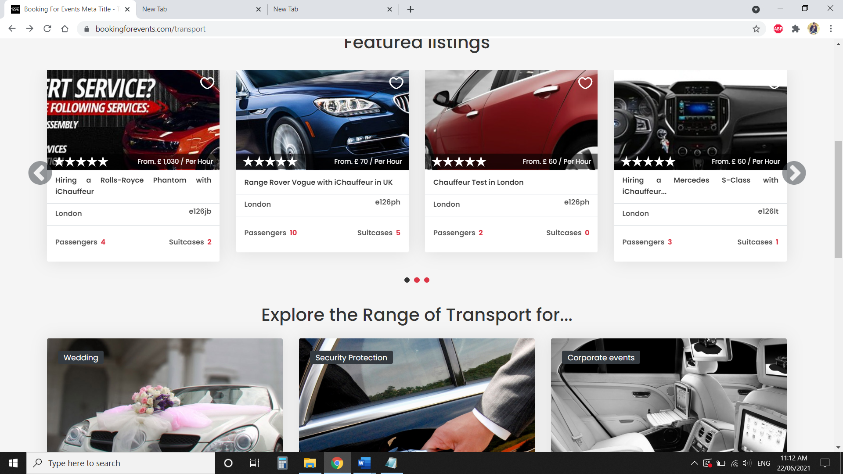

45 Characters is may dalo

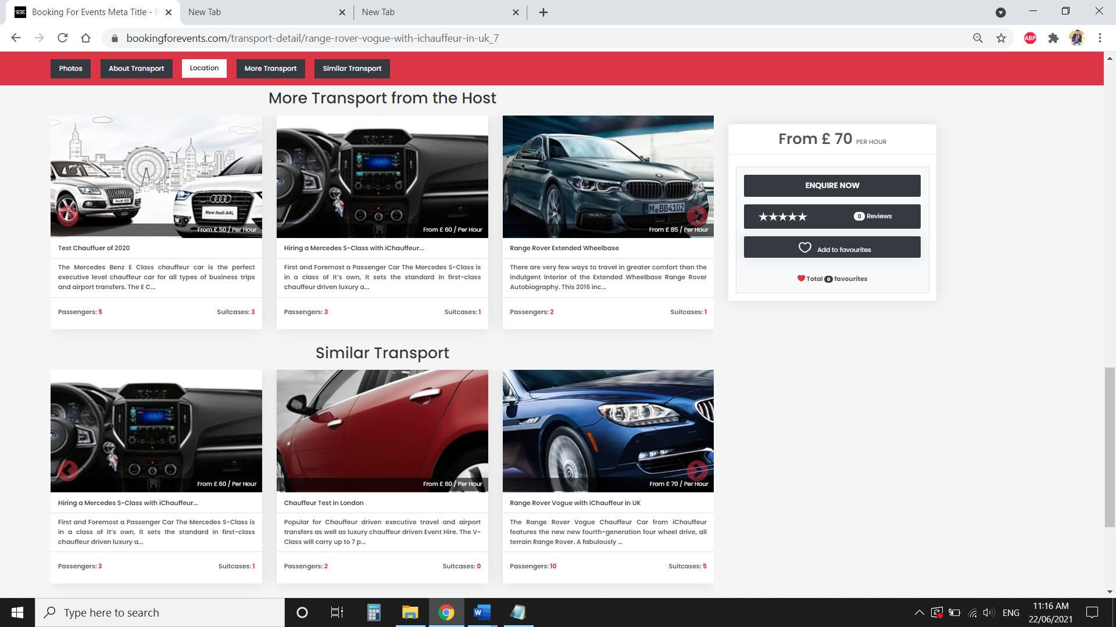

45 Characters is may dalo

150 Characters is may dalo

45 Characters is may dalo

150 Characters is may dalo